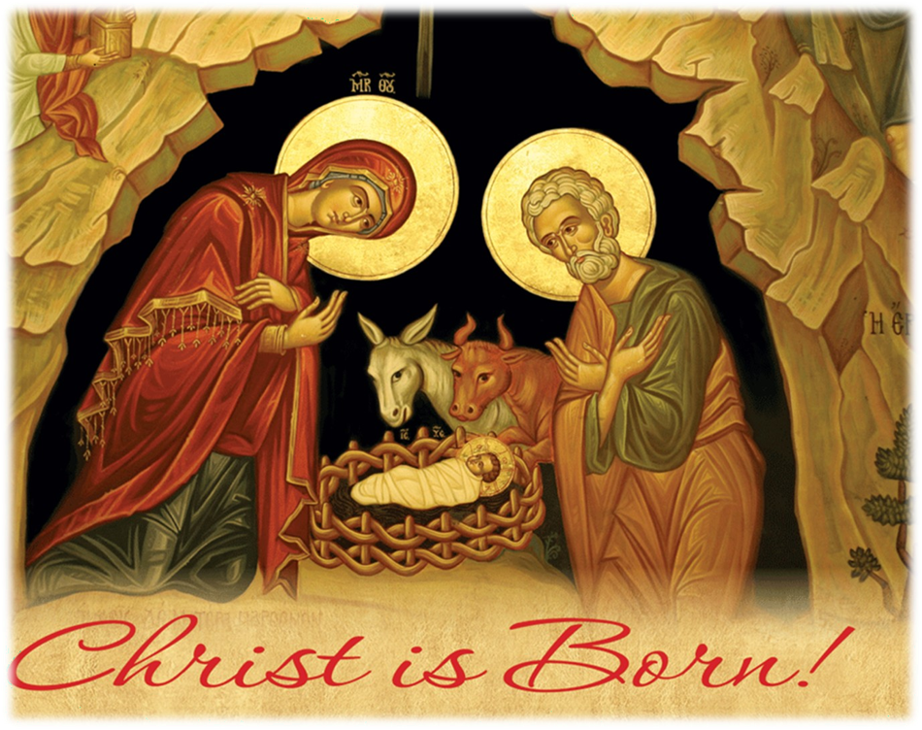
St. Nicholas Serbian Orthodox Church- Johnstown

CHRISTMAS SCHEDULE

30th SUNDAY AFTER PENTECOST (January 3rd) – The Holy Fathers
(Serbian Fathers` Day)
10:00 AM – Divine Liturgy - Liturgical Readings: Epistle (Col. 3, 4-11) & Gospel (Lk. 14, 16-24)

WEDNESDAY (January 6th) - Christmas Eve
9:30 AM – Divine Liturgy (of St. Basil the Great)
7:00 PM - Vigil and Blessing of the Yule Log (Badnjak) followed by blessing of Cesnica with Golden Coin and Holy Fathers’ message for everyone

THURSDAY (January 7th) – The Nativity of our Lord God and Savior Jesus Christ - BOŽIĆ
10:00 AM – Divine Liturgy

FRIDAY (January 8th) – Synaxis of the Most Holy Theotokos
9:30 AM – Divine Liturgy

SATURDAY (January 9th) - Holy Apostle, Protomartyr and Archdeacon Stephen
9:30 AM – Divine Liturgy

31st SUNDAY AFTER PENTECOST (January 10th) – The Holy God-bearing Fathers
10:00 AM – Divine Liturgy

Peace from God! Christ is born!
Happy and blessed New Year 2021 to all our Parishioners!

